LAB REPORT 04
Introduction to Computational Modeling
Practice Problem 1: Aircraft Fuel Consumption Prediction Model
Details: An aircraft Flight Management System (FMS) needs to estimate fuel remaining where consumption is linear with flight time.
Mathematical Model: F(t) = F_0 - rt where F_0 = 12,000 kg (initial fuel) and r = 250 kg/hour (consumption rate).
Tasks: Calculate remaining fuel after 5, 10, and 20 hours, generate a graph, and find when fuel reaches 2,000 kg.
MATLAB Implementation Code:
clc; clear;
% Aircraft parameters
initialFuel = 12000;
consumptionRate = 250;

% Flight time
t = 0:1:40;

% Linear fuel model
fuelRemaining = initialFuel - consumptionRate*t;

% Display selected values
time = [5 10 20];
fuel = initialFuel - consumptionRate*time;

disp("Flight Time (hours)");
disp(time);
disp("Remaining Fuel (kg)");
disp(fuel);

% Find time when fuel reaches 2000 kg
requiredFuel = 2000;
flightTime = (initialFuel-requiredFuel)/consumptionRate;
fprintf("Fuel reaches 2000 kg after %.2f hours\n", flightTime);

% Plot
plot(t, fuelRemaining, 'LineWidth', 2);
xlabel('Flight Time (hours)');
ylabel('Remaining Fuel (kg)');
title('Aircraft Fuel Consumption Linear Model');
grid on;
Simulation Output (Graph & Text Output):
Flight Time (hours):
5 10 20
Remaining Fuel (kg):
10750 9500 7000
Fuel reaches 2000 kg after 40.00 hours
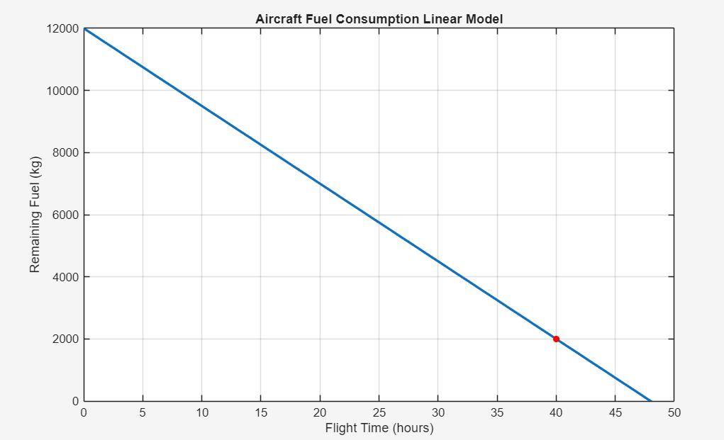
Practice Problem 2: Aircraft Altitude Sensor Calibration Model
Details: An aircraft's pressure altitude sensor changes voltage output linearly with altitude.
Mathematical Model: V = mH + c where V is sensor voltage, H is altitude, m is sensitivity coefficient, and c is the initial offset voltage. Given points: (0m, 0.5V) and (4000m, 5.7V), yielding V = 0.0013H + 0.5.
Tasks: Determine linear calibration equation, estimate sensor voltage at 2500m, 3500m, and 5000m, and plot altitude vs voltage.
MATLAB Implementation Code:
clc; clear;
% Calibration data
Altitude = [0 1000 2000 3000 4000];
Voltage = [0.5 1.8 3.1 4.4 5.7];

% Linear fitting
model = polyfit(Altitude, Voltage, 1);
m = model(1);
c = model(2);

fprintf("Calibration Equation:\n");
fprintf("V = %.4fH + %.2f\n", m, c);

% Predict voltage
newAltitude = [2500 3500 5000];
predictedVoltage = m*newAltitude + c;
disp("Altitude");
disp(newAltitude);
disp("Voltage");
disp(predictedVoltage);

% Plot
plot(Altitude, Voltage, 'o');
hold on;
plot(newAltitude, predictedVoltage, '*');
xlabel("Altitude (m)");
ylabel("Sensor Voltage (V)");
title("Altitude Sensor Calibration Model");
grid on;
Simulation Output (Graph & Text Output):
Calibration Equation:
V = 0.0013H + 0.50
Altitude:
2500 3500 5000
Voltage:
3.7500 5.0500 7.0000
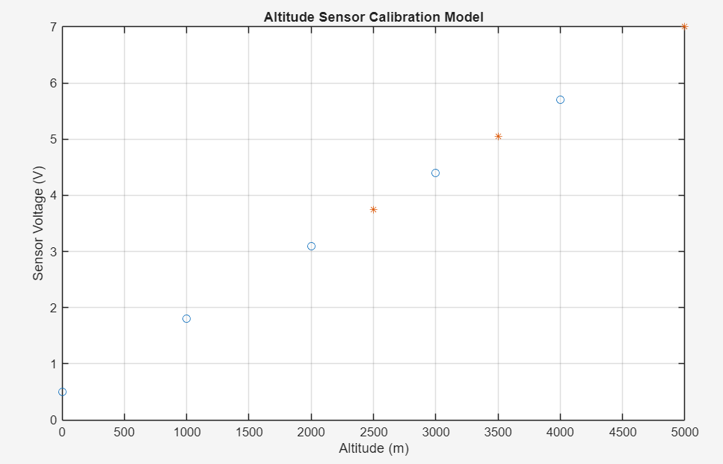
Practice Problem 3: Aircraft Communication System Signal Attenuation Model
Details: Signal strength loss decreases linearly as the distance between the aircraft and the ground station increases.
Mathematical Model: S(d) = S_0 - kd where S(d) is received signal strength (dBm), S_0 is initial strength (-20 dBm), k is the attenuation coefficient (0.3), and d is distance (km).
Tasks: Create a linear attenuation model, predict signal strength at 250km, 300km, and 400km, find maximum communication range when strength reaches -100 dBm, and plot signal loss vs distance.
MATLAB Implementation Code:
clc; clear;
% Communication data
distance = [0 50 100 150 200];
signal = [-20 -35 -50 -65 -80];

% Linear model
model = polyfit(distance, signal, 1);
k = model(1);
S0 = model(2);

fprintf("Signal Model:\n");
fprintf("S = %.3fd + %.2f\n", k, S0);

% Prediction
newDistance = [250 300 400];
predictedSignal = k*newDistance + S0;
disp("Distance");
disp(newDistance);
disp("Signal Strength");
disp(predictedSignal);

% Find communication limit
limit = -100;
range = (limit - S0)/k;
fprintf("Maximum communication range = %.2f km\n", range);

% Plot
plot(distance, signal, 'o');
hold on;
plot(newDistance, predictedSignal, '*');
xlabel("Distance (km)");
ylabel("Signal Strength (dBm)");
title("Aircraft Communication Signal Attenuation");
grid on;
Simulation Output (Graph & Text Output):
Signal Model:
S = -0.300d + -20.00
Distance:
250 300 400
Signal Strength:
-95.0000 -110.0000 -140.0000
Maximum communication range = 266.67 km


